**CHANDIGARH COLLEGE OF ENGINEERING AND TECHNOLOGY (DEGREE WING)**

Department of Computer Science & Engineering



**WEB TECHNOLOGY PRACTICAL FILE**

**Date:** 22nd March 2022

# Submitted By: Submitted To:

Neha Bhagat Mr. Sudhakar

CO21371

CSE 4th Sem

**PRACTICAL 4**

**AIM: JAVASCRIPT LAB PRACTICAL 1**

# #Exercise1: Changing Text Program:

<!DOCTYPE html>

<html lang="en">

<head>

<meta charset="UTF-8">

<title>Exercise #1: Changing text</title>

<style>

#mydiv {

width: 300px; height: 50px;

line-height: 50px; /* for vertical alignment of text */ text-align: center;

border: 1px solid black; background-color: yellow; font-size: 2em;

font-weight: bold;

}

</style>

<script>

function settext(element, text) { element.innerHTML = text;

}

</script>

</head>

<body>

<div id="mydiv" onmouseover="settext(this, 'Can I help you?');" onmouseout="settext(this, 'Hello world!');"> Hello world</div>

</body>

</html>

**Output:**

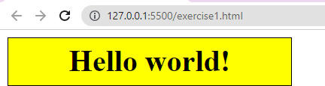 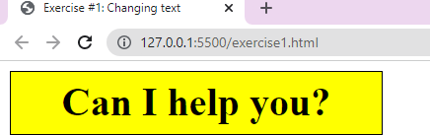

# #Exercise2: Changing colors Program:

<!DOCTYPE html>

<html lang="en">

<head>

<meta charset="UTF-8">

<title>Exercise #2: Changing colors</title>

<style>

#mydiv {

width: 200px; height: 200px;

border: 1px solid black;

}

</style>

<script>

/* TODO: write JS code here */ function changeColor() {

var color = this.style.backgroundColor; var newcolor;

switch (color) { case "red":

newcolor = "green"; break;

case "green":

newcolor = "blue"; break;

case "blue":

newcolor = "red"; break;

default: // this should never happen newcolor = "blue;";

}

this.style.backgroundColor = newcolor;

}

function init() {

var mydiv = document.getElementById("mydiv"); mydiv.style.backgroundColor = "blue"; mydiv.onclick = changeColor;

}

window.onload = init;

</script>

</head>

<body>

<div id="mydiv"></div>

</body>

</html>

# Output:

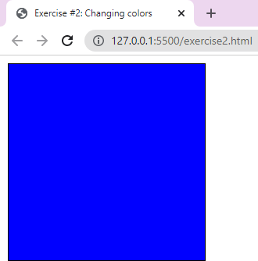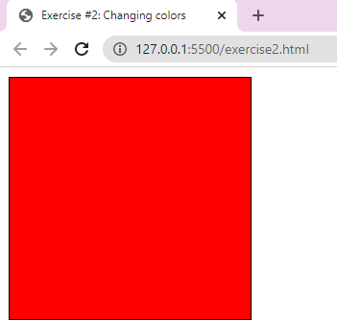

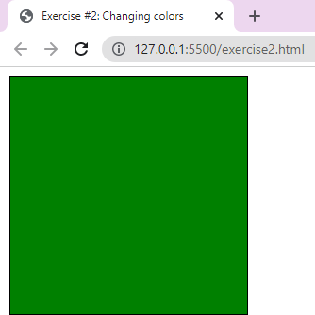

**#Exercise2b: Randomize initial color Program:**

<!DOCTYPE html>

<html lang="en">

<head>

<meta charset="UTF-8">

<title>Exercise #2: Changing colors</title>

<style>

#mydiv {

width: 200px; height: 200px;

border: 1px solid black;

}

</style>

<script>

var colors = ["blue", "green", "red", "magenta", "yellow", "orange", "black", "brown"];

function changeColor() {

var color = this.style.backgroundColor;

var idx = colors.indexOf(color); // get index of current color idx++; // change to next color

if (idx == colors.length) { // start over after the last color idx = 0;

}

this.style.backgroundColor = colors[idx];

}

function init() {

var mydiv = document.getElementById("mydiv");

var rnd = Math.floor((Math.random() * colors.length)); // random

color index

mydiv.style.backgroundColor = colors[rnd]; mydiv.onclick = changeColor;

}

window.onload = init;

</script>

</head>

<body>

<div id="mydiv"></div>

</body>

</html>

# Output:

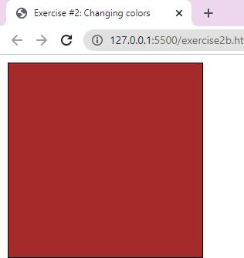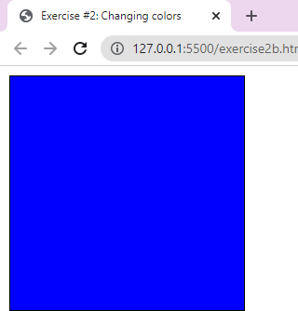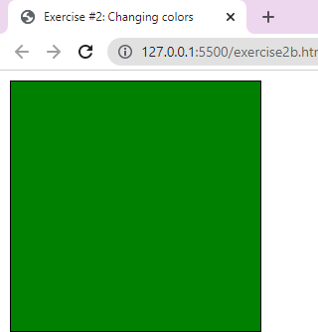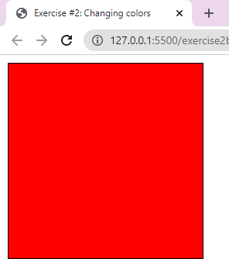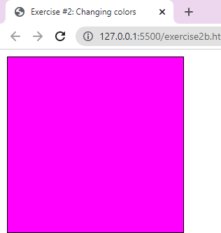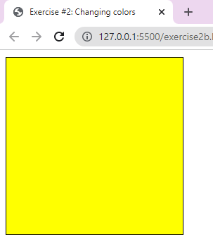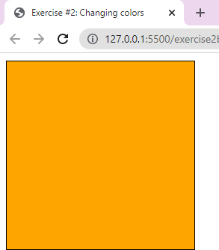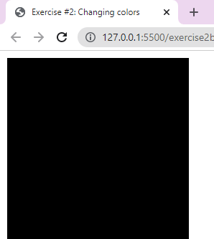

**#Exercise3: Changing images Program:**

<!DOCTYPE html>

<html lang="en">

<head>

<meta charset="UTF-8">

<title>Exercise #3: Changing images</title>

<script>

function changeImage() {

var s = document.getElementById("country"); var img = document.getElementById("img");

img.src = "images/" + s.options[s.selectedIndex].value; img.alt = s.options[s.selectedIndex].text;

}

</script>

</head>

<body>

<form name="form">

<select name="country" id="country" onchange="changeImage();">

<option value="exercise3.png">Select</option>

<option value="exercise3_2.png">Norway</option>

</select>

</form>

<img id="img" src="images/exercise3.png" style="border: 1px solid black" alt="No image selected"/>

</body>

</html>

# Output:

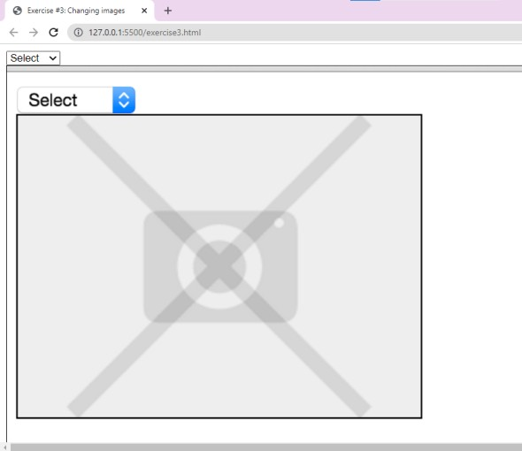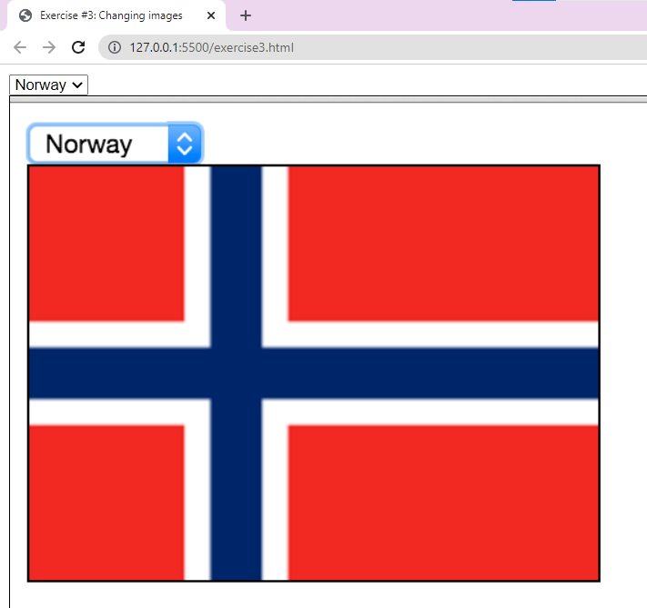

**#Exercise4: Formatting text Program:**

<!DOCTYPE html>

<html lang="en">

<head>

<meta charset="UTF-8">

<title>Exercise #4: Formatting text</title>

<style>

div {

width: 600px; height: 100px;

border: 1px solid black; margin-top: 10px;

/* default options */ font-family: Arial; font-size: 12pt;

}

</style>

<script>

function changefont_family(){

var text = document.getElementById("text"); var f = document.getElementById("font_family"); text.style.fontFamily=f.value;

}

function changefont_size(){

var text = document.getElementById("text"); var s = document.getElementById("font_size"); text.style.fontSize = s.value;

}

function changefont_italic(){

var text = document.getElementById("text");

var i = document.getElementById("font_italic").checked;//to se ig option selected or not

text.style.fontStyle = (i ? "italic" : "normal");

}

function changefont_bold() {

var text = document.getElementById("text");

var b = document.getElementById("font_bold").checked; text.style.fontWeight = (b ? "bold" : "normal");

}

function changefont_underline() {

var text = document.getElementById("text");

var u = document.getElementById("font_underline").checked; text.style.textDecoration = (u ? "underline" : "none");

}

</script>

</head>

<body>

<form name="form">

<select name="font_family" id="font_family" onchange="changefont_family();">

<option value="Arial" selected>Arial</option>

<option value="Verdana">Verdana</option>

<option value="Helvetica">Helvetica</option>

<option value="Times New Roman">Times New Roman</option>

<option value="Courier New">Courier New</option>

</select>

<select name="font_size" id="font_size" onchange="changefont_size();">

<option value="8pt">8pt</option>

<option value="10pt">10pt</option>

<option value="12pt" selected>12pt</option>

<option value="14pt">14pt</option>

<option value="16pt">16pt</option>

</select>

<label>Italic <input type="checkbox" name="font_italic" id="font_italic" onchange="changefont_italic();"></label>

<label>Bold <input type="checkbox" name="font_bold" id="font_bold" onchange="changefont_bold();"></label>

<label>Underline <input type="checkbox" name="font_underline" id="font_underline" onchange="changefont_underline();"></label>

</form>

<div id="text">The quick brown fox jumps over the lazy dog</div>

</body>

</html>

# Output:

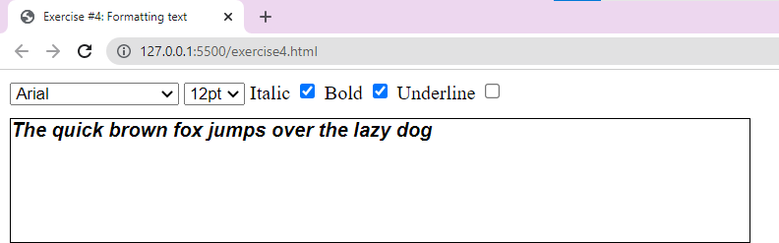

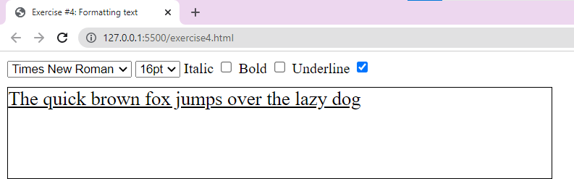

**#Exercise5: Input check Program:**

<!DOCTYPE html>

<html lang="en">

<head>

<meta charset="UTF-8">

<title>Exercise #5: Input check</title>

<style>

* {

font-family: Arial, sans-serif;

}

.err {

color: red;

font-size: 0.7em;

}

</style>

<script>

function checkPasswords() {

var pw1 = document.getElementById("password1").value; var pw2 = document.getElementById("password2").value; var pw1check = document.getElementById("pw1_check"); var pw2check = document.getElementById("pw2_check");

var isError = false; if (pw1.length > 0) {

if (pw1.length < 6) { pw1check.innerHTML = "Too short"; isError = true;

}

else {

pw1check.innerHTML = "";

}

if (pw2.length > 0 && pw1 !== pw2) {

pw2check.innerHTML = "the two passwords don't match"; isError = true;

}

else {

pw2check.innerHTML = "";

}

}

else {

pw1check.innerHTML = "";

}

// show the submit button only if everything is OK var btn = document.getElementById("submitBtn");

if (pw1.length > 0 && pw2.length > 0 && !isError) { btn.style.display = "";

}

else {

btn.style.display = "none";

}

}

window.onload = function () {

// hide the submit button initially document.getElementById("submitBtn").style.display = "none";

}

</script>

</head>

<body>

<form name="pw">

<table>

<tr>

<td>Password (min 6 characters):</td>

<td><input type="password" name="password1" id="password1" size="10" placeholder="Password" onkeyup="checkPasswords()"></td>

<td>

<div id="pw1_check" class="err"></div>

</td>

</tr>

<tr>

<td>Repeat password:</td>

<td><input type="password" name="password2" id="password2" size="10" placeholder="Password" onkeyup="checkPasswords()"></td>

<td>

<div id="pw2_check" class="err"></div>

</td>

</tr>

</table>

<input type="submit" value="Submit" id="submitBtn"/>

</form>

</body>

</html>

# Output:

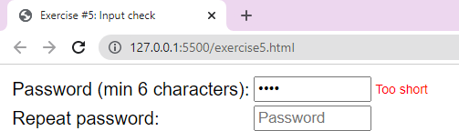

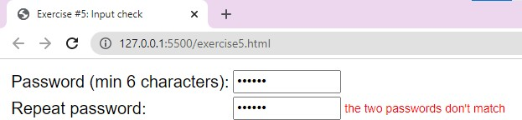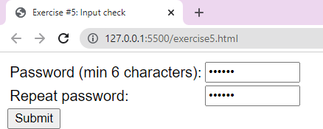

**#Exercise6: Content show/hide Program:**

<!DOCTYPE html>

<html lang="en">

<head>

<meta charset="UTF-8">

<title>Exercise #6: Content show/hide</title>

<style>

* {

font-family: Georgia, serif;

}

article {

width: 400px;

border: 1px solid grey; background-color: #ececec; position: relative; margin: 5px;

}

article h2 {

margin: 0px; padding: 10px; font-size: 1.5em;

}

article .showlink { position: absolute; right: 10px;

top: 20px;

}

article .text {

background-color: white; padding: 10px;

font-family: Verdana, sans-serif; font-size: 0.9em;

color: #a9a9a9;

}

</style>

<script>

/* TODO this is for you to complete */

function hide(id) {

var element = document.getElementById(id); element.style.display = "none";

}

function show(id) {

var element = document.getElementById(id); element.style.display = "";

}

</script>

</head>

<body>

<article>

<h2>What is lorem ipsum?</h2>

<div id="p1_show" class="showlink"><a href="#" onclick="show('p1_text');hide('p1_show');">Show</a></div>

<div id="p1_text" class="text" style="display:none">

<p>Lorem Ipsum is simply dummy text of the printing and typesetting industry. Lorem Ipsum has been the

industry's standard dummy text ever since the 1500s, when an unknown printer took a galley of type and

scrambled it to make a type specimen book. It has survived not only five centuries, but also the leap into

electronic typesetting, remaining essentially unchanged. It was popularised in the 1960s with the release of

Letraset sheets containing Lorem Ipsum passages, and more recently with desktop publishing software like

Aldus PageMaker including versions of Lorem Ipsum.</p>

<p><a href="#" onclick="show('p1_show');hide('p1_text');">Hide</a></p>

</div>

</article>

<article>

<h2>Why do we use it?</h2>

<div id="p2_show" class="showlink"><a href="#" onclick="show('p2_text');hide('p2_show');">Show</a></div>

<div id="p2_text" class="text" style="display:none">

<p>It is a long established fact that a reader will be distracted by the readable content of a page when looking

at its layout. The point of using Lorem Ipsum is that it has a more- or-less normal distribution of letters,

as opposed to using 'Content here, content here', making it look like readable English. Many desktop

publishing packages and web page editors now use Lorem Ipsum as their default model text, and a search for

'lorem ipsum' will uncover many web sites still in their infancy.

Various versions have evolved over the

years, sometimes by accident, sometimes on purpose (injected humour and the like).</p>

<p><a href="#" onclick="show('p2_show');hide('p2_text');">Hide</a></p>

</div>

</article>

<article>

<h2>Where does it come from?</h2>

<div id="p3_show" class="showlink"><a href="#" onclick="show('p3_text');hide('p3_show');">Show</a></div>

<div id="p3_text" class="text" style="display:none">

<p>Contrary to popular belief, Lorem Ipsum is not simply random text. It has roots in a piece of classical Latin

literature from 45 BC, making it over 2000 years old. Richard McClintock, a Latin professor at

Hampden-Sydney College in Virginia, looked up one of the more obscure Latin words, consectetur, from a Lorem

Ipsum passage, and going through the cites of the word in classical literature, discovered the undoubtable

source. Lorem Ipsum comes from sections 1.10.32 and 1.10.33 of "de Finibus Bonorum et Malorum" (The Extremes

of Good and Evil) by Cicero, written in 45 BC. This book is a treatise on the theory of ethics, very popular

during the Renaissance. The first line of Lorem Ipsum, "Lorem ipsum dolor sit amet..", comes from a line in

section 1.10.32.</p>

<p>The standard chunk of Lorem Ipsum used since the 1500s is reproduced below for those interested. Sections

1.10.32 and 1.10.33 from "de Finibus Bonorum et Malorum" by Cicero are also reproduced in their exact

original form, accompanied by English versions from the 1914 translation by H. Rackham.</p>

<p><a href="#" onclick="show('p3_show');hide('p3_text');">Hide</a></p>

</div>

</article>

</body>

</html>

# Output:

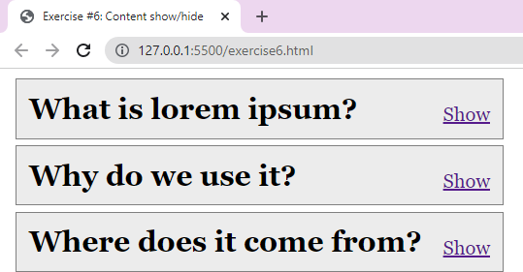

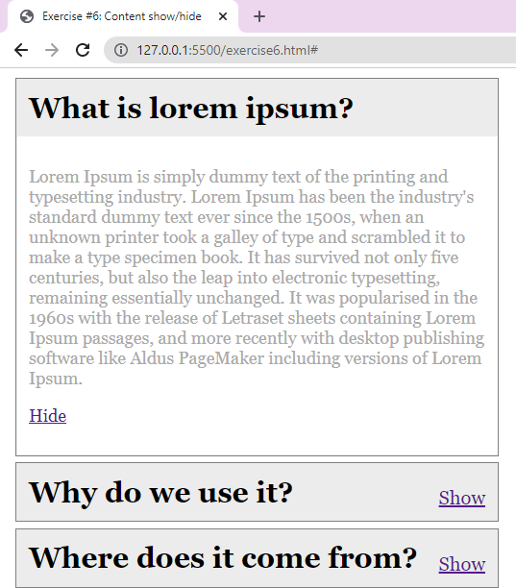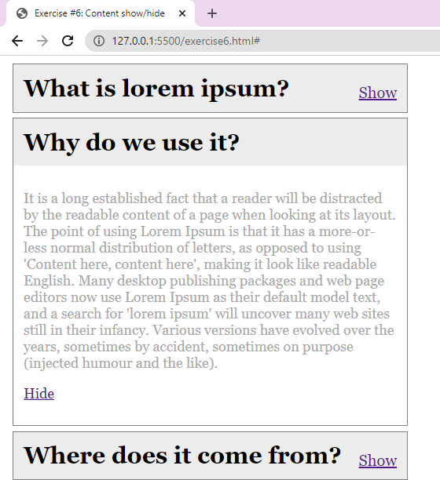

**#Exercise7: Simple playlist Program:**

.html

<!DOCTYPE html>

<html lang="en">

<head>

<meta charset="UTF-8">

<title>Exercise #7: Simple playlist</title>

<link rel="stylesheet" href="exercise7.css">

<script>

/* TODO this is for you to complete */ function handleButtonClick() {

var textInput = document.getElementById("songTextInput"); var songName = textInput.value;

if (songName == "") { alert("Please enter a song");

}

else {

var li = document.createElement("li"); li.innerHTML = songName;

var ul = document.getElementById("playlist"); ul.appendChild(li);

}

}

window.onload = function () { document.getElementById("addButton").onclick = handleButtonClick;

}

</script>

</head>

<body>

<form>

<input type="text" id="songTextInput" size="40" placeholder="Song name">

<input type="button" id="addButton" value="Add Song">

</form>

<ul id="playlist">

</ul>

</body>

</html>

.css

body {

font-family: Arial, sans-serif;

}

ul#playlist {

border: 1px solid #a9a9a9; border-radius: 5px; margin-top: 10px;

padding: 0px;

list-style-type: none;

}

ul#playlist li {

border-bottom: 1px solid #a9a9a9; padding: 10px;

background-image: linear-gradient(#f9f9f9, #e3e3e3);

}

ul#playlist li:last-child { border-bottom: none;

border-bottom-right-radius: 5px; border-bottom-left-radius: 5px;

}

ul#playlist li:first-child { border-top-right-radius: 5px; border-top-left-radius: 5px;

}

# Output:

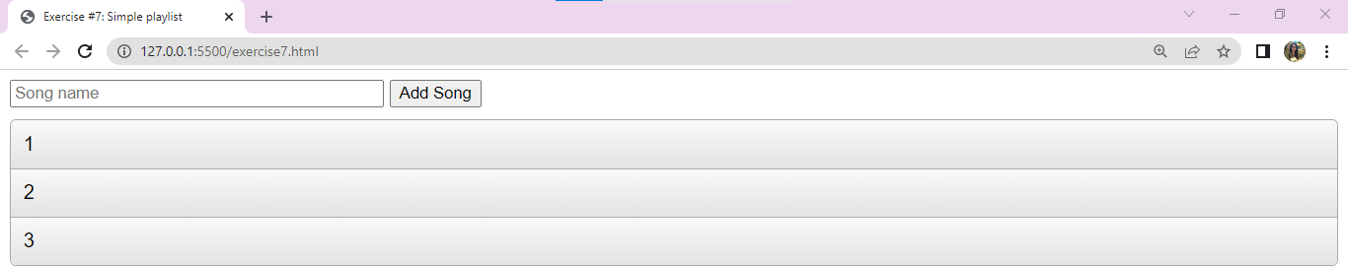

**#Exercise7b: Advanced playlist Program:**

.html

<!DOCTYPE html>

<html lang="en">

<head>

<meta charset="UTF-8">

<title>Exercise #7b: Advanced playlist</title>

<link rel="stylesheet" href="exercise7.css">

<script>

function handleButtonClick() {

var textInput = document.getElementById("songTextInput"); var songName = textInput.value;

if (songName == "") { alert("Please enter a song");

}

else {

var li = document.createElement("li"); li.innerHTML = songName;

var ul = document.getElementById("playlist");

// del is an image

var del = document.createElement("img"); del.src = "delete.png";

del.className = "delete"; del.onclick = delSong; li.appendChild(del); ul.appendChild(li);

}

}

function delSong() {

// find the parent (li) element var song = this.parentNode;

// delete the song (li) from the list (ul) song.parentNode.removeChild(song);

}

window.onload = function () { document.getElementById("addButton").onclick = handleButtonClick;

}

</script>

</head>

<body>

<form>

<input type="text" id="songTextInput" size="40" placeholder="Song name">

<input type="button" id="addButton" value="Add Song">

</form>

<ul id="playlist">

</ul>

</body>

</html>

.css

body {

font-family: Arial, sans-serif;

}

ul#playlist {

border: 1px solid #a9a9a9; border-radius: 5px; margin-top: 10px;

padding: 0px;

list-style-type: none;

}

ul#playlist li {

border-bottom: 1px solid #a9a9a9; padding: 10px;

background-image: linear-gradient(#f9f9f9, #e3e3e3);

}

ul#playlist li:last-child { border-bottom: none;

border-bottom-right-radius: 5px; border-bottom-left-radius: 5px;

}

ul#playlist li:first-child { border-top-right-radius: 5px; border-top-left-radius: 5px;

}

/* added for 7b */ ul#playlist li {

position: relative;

}

img.delete {

position: absolute; right: 5px;

top: 5px;

width: 32px;

}

# Output:

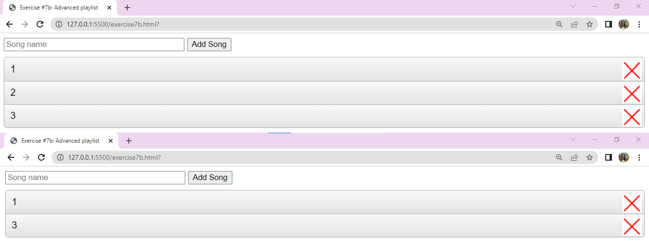

**#Exercise8: Color picker Program:**

.html

<!DOCTYPE html>

<html lang="en">

<head>

<meta charset="UTF-8">

<title>Exercise #8: Color picker</title>

<style>

#colors {

width: 576px; height: 216px;

border: 1px solid black;

}

#selected {

margin-top: 5px; padding: 5px;

text-align: center; width: 120px; height: 1em;

border: 1px solid black;

}

.choice {

float:left; width: 20px; height: 20px;

border: 1px solid black; margin: 1px;

}

</style>

<script src="exercise8.js"></script>

</head>

<body>

<div id="colors"></div>

<div id="selected"></div>

</body>

</html>

.js

function initGrid() {

// collect colors in an array var colors = [];

var range = ["00", "33", "66", "99", "cc", "ff"];

for (var r = 0; r < range.length; r++) { for (var g = 0; g < range.length; g++) {

for (var b = 0; b < range.length; b++) { colors.push("#" + range[r] + range[g] + range[b]);

}

}

}

// TODO complete the rest

var cdiv = document.getElementById("colors"); for (var i = 0; i < colors.length; i++)

{

var tile = document.createElement("div"); tile.className = "choice"; tile.style.backgroundColor = colors[i]; tile.addEventListener("click", tileClicked); cdiv.appendChild(tile);

}

}

function tileClicked() {

var color = this.style.backgroundColor;

var sel = document.getElementById("selected"); sel.style.backgroundColor = color; sel.innerHTML = color;

}

window.onload = function () { initGrid();

}

# Output:

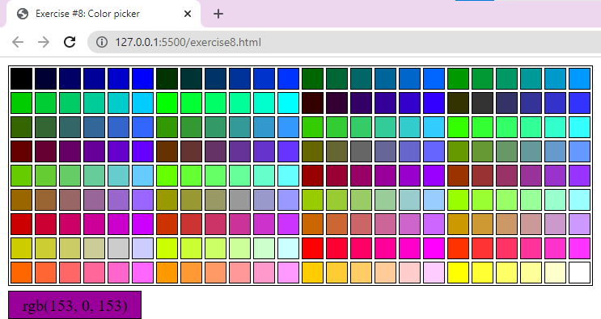

**#Exercise9: Labyrinth game Program:**

.html

<!DOCTYPE html>

<html lang="en">

<head>

<meta charset="UTF-8">

<title>Exercise #9: Labyrinth game</title>

<script src="labyrinth.class.js"></script>

<script src="game.js"></script>

</head>

<body>

<div id="map"></div>

</body>

</html>

Game.js

/* TODO implement game logic here */ window.onload = function () {

let labyrinth = new Labyrinth(); labyrinth.printConsole(); labyrinth.printDisplay('map'); document.onkeydown = function (event) {

var char = event.keyCode; if (char == 37) {

if (labyrinth.playerPos.x - 1 >= 0 && labyrinth.map[labyrinth.playerPos.y][labyrinth.playerPos.x - 1] == 0) {

labyrinth.playerPos.x -= 1; labyrinth.player.style.left = (labyrinth.playerPos.x *

CELL_SIZE).toString() + 'px';

}

} else if (char == 40) {

if (labyrinth.playerPos.y + 1 < labyrinth.height && labyrinth.map[labyrinth.playerPos.y+1][labyrinth.playerPos.x] == 0) {

labyrinth.playerPos.y += 1; labyrinth.player.style.top = (labyrinth.playerPos.y *

CELL_SIZE).toString() + 'px';

}

} else if (char == 39) {

if (labyrinth.playerPos.x + 1 < labyrinth.width && labyrinth.map[labyrinth.playerPos.y][labyrinth.playerPos.x + 1] == 0) {

labyrinth.playerPos.x += 1; labyrinth.player.style.left = (labyrinth.playerPos.x *

CELL_SIZE).toString() + 'px';

}

} else if (char == 38) {

if (labyrinth.playerPos.y - 1 >= 0 && labyrinth.map[labyrinth.playerPos.y-1][labyrinth.playerPos.x] == 0) {

labyrinth.playerPos.y -= 1; labyrinth.player.style.top = (labyrinth.playerPos.y *

CELL_SIZE).toString() + 'px';

}

}

if(labyrinth.playerPos.x == labyrinth.end.x && labyrinth.playerPos.y == labyrinth.end.y){

alert("Congratulations!");

}

}

}/* TODO implement game logic here */

Labyrinth.js

var CELL_SIZE = 40;

function Labyrinth()

{

this.map = [

[0, 0, 1, 1, 1, 0],

[1, 0, 0, 0, 1, 0],

[1, 0, 1, 0, 0, 0],

[1, 0, 1, 1, 1, 0],

[1, 0, 0, 0, 1, 0]];

/* TODO implement core labyrinth functionality here */ this.printConsole = function ()

{

this.height = this.map.length; this.width = this.map[0].length; let str = "";

for (let i = 0; i < this.height; i++)

{

for (let j = 0; j < this.width; j++)

{

if (this.map[i][j] == 0)

{

str += ' ';

} else

{

str += '*';

}

}

str += '\n';

}

console.log(str);

}

this.printDisplay = function (id)

{

let element = document.getElementById(id); element.style.position = "relative";

element.style.height = (this.height * CELL_SIZE).toString() + 'px'; element.style.width = (this.width * CELL_SIZE).toString() + 'px'; element.style.border = "1px solid black";

for (let i = 0; i < this.height; i++) { for (let j = 0; j < this.width; j++) {

let cell = document.createElement('div'); cell.style.height = CELL_SIZE.toString() + 'px'; cell.style.width = CELL_SIZE.toString() + 'px'; cell.style.position = "absolute";

cell.style.left = (CELL_SIZE * j).toString() + 'px'; cell.style.top = (CELL_SIZE * i).toString() + 'px'; if (this.map[i][j] == 0) {

cell.style.backgroundColor = "white";

} else {

cell.style.backgroundColor = "grey";

}

element.appendChild(cell);

}

}

}

this.start = { x: 0, y: 0 };

this.end = { x: 5, y: 4 }; this.playerPos = {x:0,y:0};

this.player = document.createElement('div'); this.player.style.backgroundColor = "red"; this.player.style.position = "absolute";

this.player.style.left = (this.playerPos.x*CELL_SIZE).toString()+'px'; this.player.style.top = (this.playerPos.y*CELL_SIZE).toString()+'px'; this.player.style.height = CELL_SIZE.toString() + 'px'; this.player.style.width = CELL_SIZE.toString() + 'px'; this.player.style.zIndex = "30"; document.getElementById('map').appendChild(this.player);

this.destination = document.createElement('div'); this.destination.style.position = "absolute"; this.destination.style.backgroundColor = "yellow"; this.destination.style.height = CELL_SIZE.toString() + 'px'; this.destination.style.width = CELL_SIZE.toString() + 'px'; this.destination.style.left = (this.end.x*CELL_SIZE).toString()+'px'; this.destination.style.top =(this.end.y*CELL_SIZE).toString()+'px';

this.destination.style.zIndex="29";

document.getElementById('map').appendChild(this.destination);

}

# Output:

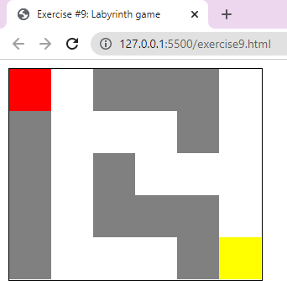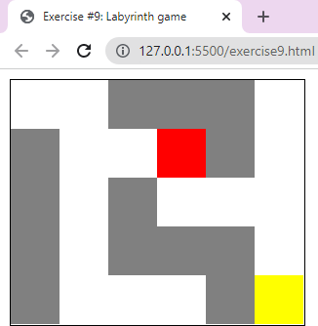

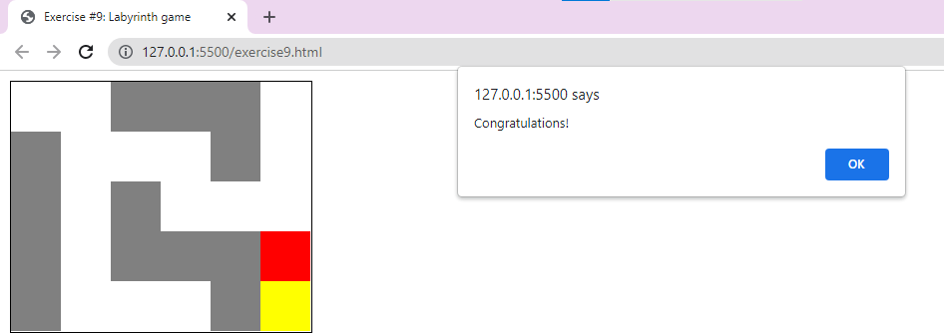

**#Exercise10: Internet security breach Program:**

1. Endless Alert

.html

<!DOCTYPE html>

<html>

<head>

<script type="text/javascript" src="exercise10a.js"></script>

<title>Endless alert</title>

</head>

<body>

</body>

</html>

.js

while(1){

alert("Your pc has a virus");

}

# Output:

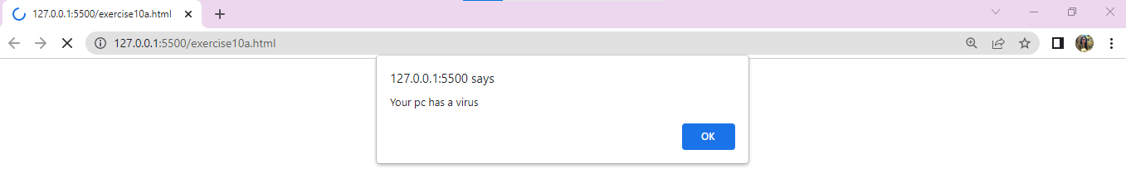

1. Whack-a-mole

.html

<!DOCTYPE html>

<html>

<head>

<script type="text/javascript" src="exercise10b.js"></script>

<title>Whack-a-mole</title>

</head>

<body>

<div style="width: 500px; height: auto; margin: 10% auto; text-align: center;">

<p id="demo"><h1>We found a virus on your PC!!</h1><br><h2>Click the button to remove it now.</h2></p>

<button id="demo" onclick="fun()" style="background-color: #0ADE32; height: 80px; width: 300px;">Click Here</button>

</div>

</body>

</html>

.js

function fun(){ var i=0; while(1){

window.open('#',i,"noscroll"); i++;

}

}

# Output:

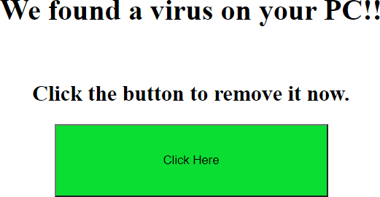

1. Sticky page

.html

<!DOCTYPE html>

<html>

<head>

<script type="text/javascript" src="exercise10c.js"></script>

<title>Sticky Page</title>

</head>

<body>

<a href="https://[www.google.com/](http://www.google.com/)"><h3>Click Here to Leave this page</h3></a>

</body>

</html>

.js

window.onbeforeunload = function() { return "leave";

}

# Output:

